A simple folding machine Waste Stripping device which sets itself and runs trouble free.

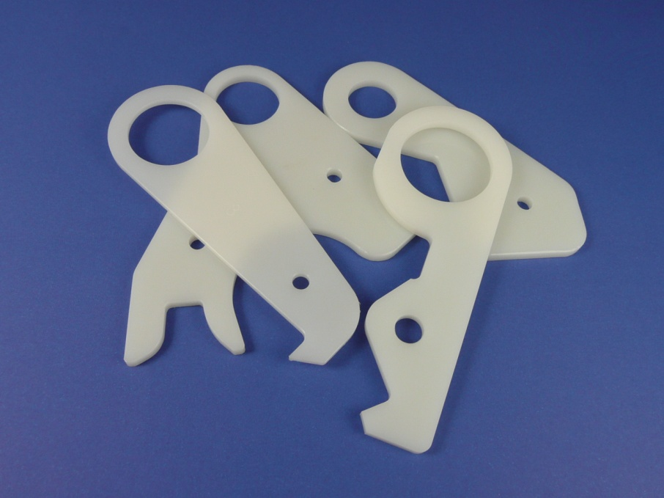

If your customer produces multiple double trims on their folding machine they already know how difficult it is to keep the original waste stripper from damaging the blades and cutting anvils when paper jams occur. The operator constantly stops the machine to remove the built up waste, uses valuable time resetting the metal hook on the waste stripper so that it fits perfectly in the centre between the cutting anvils.

We provide a remarkably simple device that eradicates the problem completely, a device that is simple to install, requires no setting, runs trouble free for many years and never damages the exit shafts.

Have your customer try the Tech-ni-Fold Waste Stripper

• No set-up required, just slide it on the lower shaft between the counter knives.
• Hardened nylon so it won’t ever scratch the shafts or damage a counter knife.
• Floats freely between counter knives, with no adjustments needed, lower part rests against frame.
• Eliminates paper jams - it’s virtually impossible to set wrong.
• Works so well you may never even need to use your existing upper waste deflector.
• Saves hours and hours of lost production.
• Cost-effective and simple to use, simplifying set-up and increasing production!

Available for the following Folding machines: Stahl, MBO, Horizon, MB, H&H, GUK & Shoei
Available in 3 thicknesses: 3mm, 4mm, 5mm

If you should have any questions or wish to place an order, please do not hesitate to contact me on: Vivienne.Edwards@Technifold.co.uk

